**Seminar Report**

**On**

**Vibration-Based Fault Detection in Drone Using Artificial Intelligence**



**Submitted By**

**ASIF NAVAS**

#### **2021-23**

#### **2nd Semester**

**Roll No: 7**

**School Of Computer Sciences**

**Mahatma Gandhi University**

**Kottayam**

**ABSTRACT**

The use of artificial intelligence (AI) to detect faults based on the vibration of multirotor arms is proposed in this research. There are some cases in which, due to accident, the arm of the multirotor crack or loosen. This is normally unnoticeable without disassembly, and if not taken care of, it would have likely resulted in a sudden loss of flight stability, which will lead to a crash. This research uses a variety of AI methodologies, including fuzzy logic, neuro-fuzzy, and neural networks (NN). Their results are compared to determine the best method in predicting the safety of the multirotor. Although fuzzy logic and neuro-fuzzy methods provides sufficient decision-making, the neuro-fuzzy approach's performance is dependent on the dataset used, as an overfit model may result in incorrect decision-making. This framework is more suitable for early prediction before flying the multirotor in the outdoor environment because the vibration data is collected in the laboratory setting without consideration of wind influence.

TABLE OF CONTENTS

**1.**  **INTRODUCTION** **1**

1.2 Objective and Scope 2

**2.** **LITERATURE REVIEW 3**

**3.** **METHODOLOGY 5**

3.1 Artificial Intelligence Algorithm 5

**4.** **RESULTS AND ANALYSIS 11**

4.1 Performance Comparison 12

4.2 User Interface 12

**5.** **CONCLUSION** **14**

**REFERENCES 15**

**1.INTRODUCTION**

These days the global market of multirotor is growingand attracting many researchers all over the globe todive into this topic. Multirotor is a type of unmanned aerial vehicle (UAV) or drone that uses more than two motors. It has been widely applied in agriculture, military surveillance, photography, road mapping, long-range communication, and navigation. Although multirotor are remotely controlled, their stability and navigation are typically aided by an onboard autopilot that relies on miniature sensors such as barometers, gyroscopes, accelerometers, and GPS. Multirotor are heavily surrounded by safety concerns. Especially in crash scenarios involving other people, animals, or items. One of the most overlooked challenges in the use of multirotor is vibration. Vibration is common in rotating machines, and vibration-based techniques are frequently used in rotating machinery condition monitoring and fault diagnosis systems.

This is one of the best ways to detect faults in the multirotor or can be applied for multirotor maintenance. If a multirotor collides or crashes, there might be some damages to the propellers or arms. The existence of such damages will produce unwanted vibrations that can significantly deteriorate the performance of the multirotor and eventually lead to a crash. These damages are sometimes not easily seen, especially on the multirotor arms, and therefore multirotor maintenance is important as it can detect these faults. The broken propeller is easily replaceable, but a faulty multirotor arm is difficult to be replaced.

A vibration-based multirotor fault detection system is proposed, with a focused on the multirotor arms. AI techniques of fuzzy logic, neuro-fuzzy, and NN are incorporated in this system to predict the safety of the multirotor, whether it is safe, partial safe, or not safe. This real-time decision-making is based on real-time data. From that, the possibility that multirotor will crash or safe to operate can be predicted.

* 1. **Objective and Scope**

The main Objective of this research is the study of the effects of the multirotor arms based on the vibration data, where healthy and faulty arms were simulated. The framework for the decision-making by the AI techniques and user interface via smartphones are other contributions of this study where the users can monitor the status of the multirotor based on the green, yellow, and red colour. whether it is safe, partial safe, or not safe.

**2. LITERATURE REVIEW**

To determine the dynamic characteristics of the multirotor frame in terms of mode shapes and natural frequencies, Verbeke and Debruyne used experimental modal analysis (EMA) and numerical simulation. This method can determine the low-vibration regions where sensitive electronics should best be mounted. Based on their performance, in order to propose an anti-vibration framework for the multirotor, including the best damper and isolator. They discovered that the structural vibration contributes a much higher vibration amplitude compared to motor vibration, and with the proposed damper and isolator, the vibration amplitude is lowered. The analysis of the random vibrations in multirotor was done by Abdulrahman Al-Mashhadani. He introduced a mathematical analysis for random vibrations and proposed a control methodology to decrease the effect of unwanted vibrations. These vibrations might affect the accuracy of the data collected by the sensors in the multirotor. No application of AI methods is integrated into the works discussed above.

A technique for fault detection of physical impairment of UAV rotor blades is proposed by Bondyra et al. Based on the characteristics of the vibration signal, faulty rotor blades and its scale can be determined by support vector machine (SVM). Pourpanah et al used a hybrid method of Q-learning Fuzzy ARTMAP classifier (QFAM) and genetic algorithm (GA) to classify between healthy and broken propeller, based on vibration signals. The healthy propeller generates a smooth signal compared to the broken propeller. Ghalamchi and Mueller presented a fault detection method for the multirotor propellers without using any external vibration sensors. The vibration signals are measured using the built-in accelerometer. This method is effective for locating a damaged propeller, but it is limited by flight trajectories.

Most of the studies performed by other researchers are offline methods, where the fault detection or decision-making is done not in real-time. Offline methods might take longer time to determine the condition of. Besides, the smartphone’s application was not incorporated in the previous studies.

**3.METHODOLOGY**

It starts with data acquisition. vibration data is collected from vibration sensors and stored in the microcontroller. The AI methods (Artificial Intelligence Algorithms) will then compute the vibration data collected and provide a decision whether the multirotor is safe, partially safe, or not safe.

**3.1 Artificial Intelligence Algorithms**

**Fuzzy Logic**

Fuzzy logic has been utilized for fault detection in many areas such as robotics, machine vision, energy, industries, etc. Here Mamdani-type fuzzy logic with four inputs and one output is used. The inputs are the vibration measured by the four sensors attached to each of the multirotor arms, which are recognized as sensor A, sensor B, sensor C, and sensor D. The output is the decision-making given by the fuzzy logic system. It is divided into three steps. The first step is fuzzification, where the input data are converted into fuzzy sets using fuzzy linguistic variables, fuzzy linguistic terms, and membership functions. At this step, a designer needs to specify the number of inputs, membership functions and type of membership function. Next is creating the rules for the fuzzy logic system and it represent human experts’ knowledge. In most cases, the rules can be determined based on human experiences or analysis conducted by the engineer. The last step is defuzzification. It is a process of producing quantifiable results in fuzzy logic for given fuzzy sets and corresponding membership functions.

**Neuro-Fuzzy**

It also known as a fuzzy neural network (FNN). A neuro-fuzzy system can be considered as a 3-layer feedforward NN, where the first layer represents input variables, the fuzzy rules as the second layer, and output variables as the third layer. It can be considered as an improvement to the neural network method in a way that prior knowledge about the training dataset can be encoded in the parameters of the neuro-fuzzy system.

In this study, the ANFIS network has four inputs (Sensors A, B, C, and D). The first layer represents the fuzzification process, the second layer represents the fuzzy rules, and the third layer normalizes the membership functions. The fourth layer is the conclusive part of fuzzy rules, and finally, the fifth layer calculates the network output, which is the decision-making regarding the drone condition. ANFIS provides good learning and prediction capabilities. However, the neuro-fuzzy technique heavily depends on the dataset.

**Artificial Neural Networks**

It can define as an interconnected assembly of simple processing elements, units, or nodes, whose functionality is inspired by the way that the human brain processes information. These large numbers of nodes are connected in layers, forming a network. NN can be divided into single-layer and multilayer NN. In the single-layer NN, also referred to as perceptron, there is only one neuron and computes only one output. For multilayer NN, there are three types of layers involved, which are input, hidden, and output layers. In the input layer, data processing takes place. Between the input and output layer, there is a hidden layer that conducts mathematical transformations by applying the numeric values called weights to the network inputs. The output layer is the last layer of the NN architecture and is the result of the data when passed through NN.

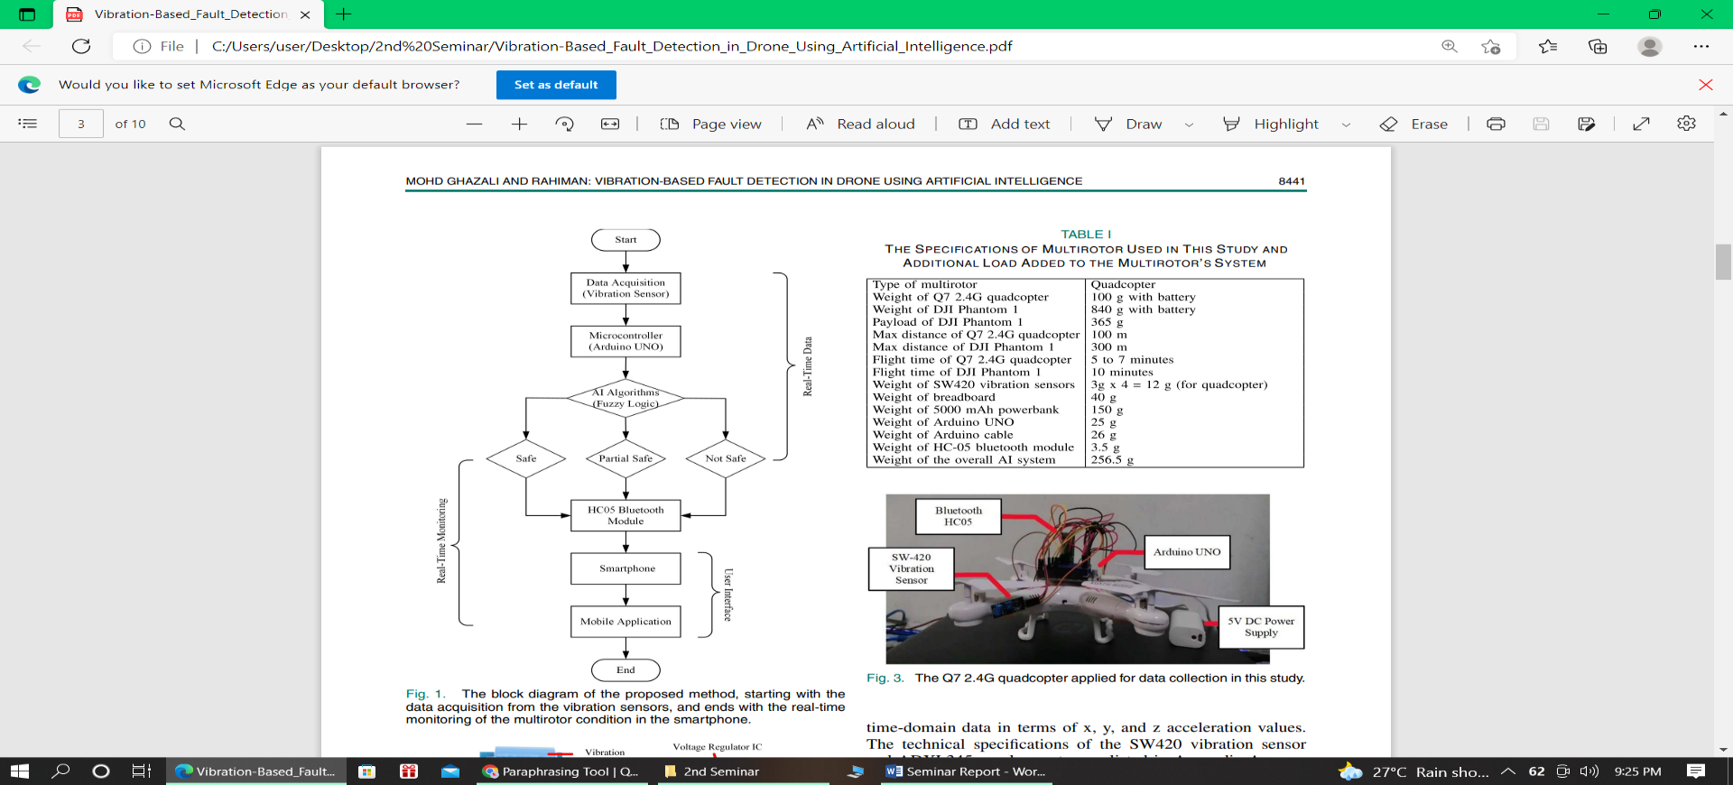

**Figure 1:** The block diagram of the proposed method.

The HC05 Bluetooth module will transmit the decision or output to the smartphone, and the user can monitor the condition of the multirotor in real-time via the mobile application created. Before the drone takes off, all vibration data is collected in an indoor environment.

The multirotor vibration is measured using the SW420 vibration sensors (see Figure 2). The integrated LM393 comparator chip has two output types: digital (based on values 0 and 1) and analogue (based on values 0 and 1). (Value is in the form of received voltage). In this study, the analogue output of the sensor will be used, with the higher the vibration, the higher the analogue output produced. The SW420 vibration sensor's sensitivity can be adjusted to the desired value by turning the potentiometer. The sensors are attached to the arms of the multirotor and are connected to the Arduino UNO pin to store the collected data.

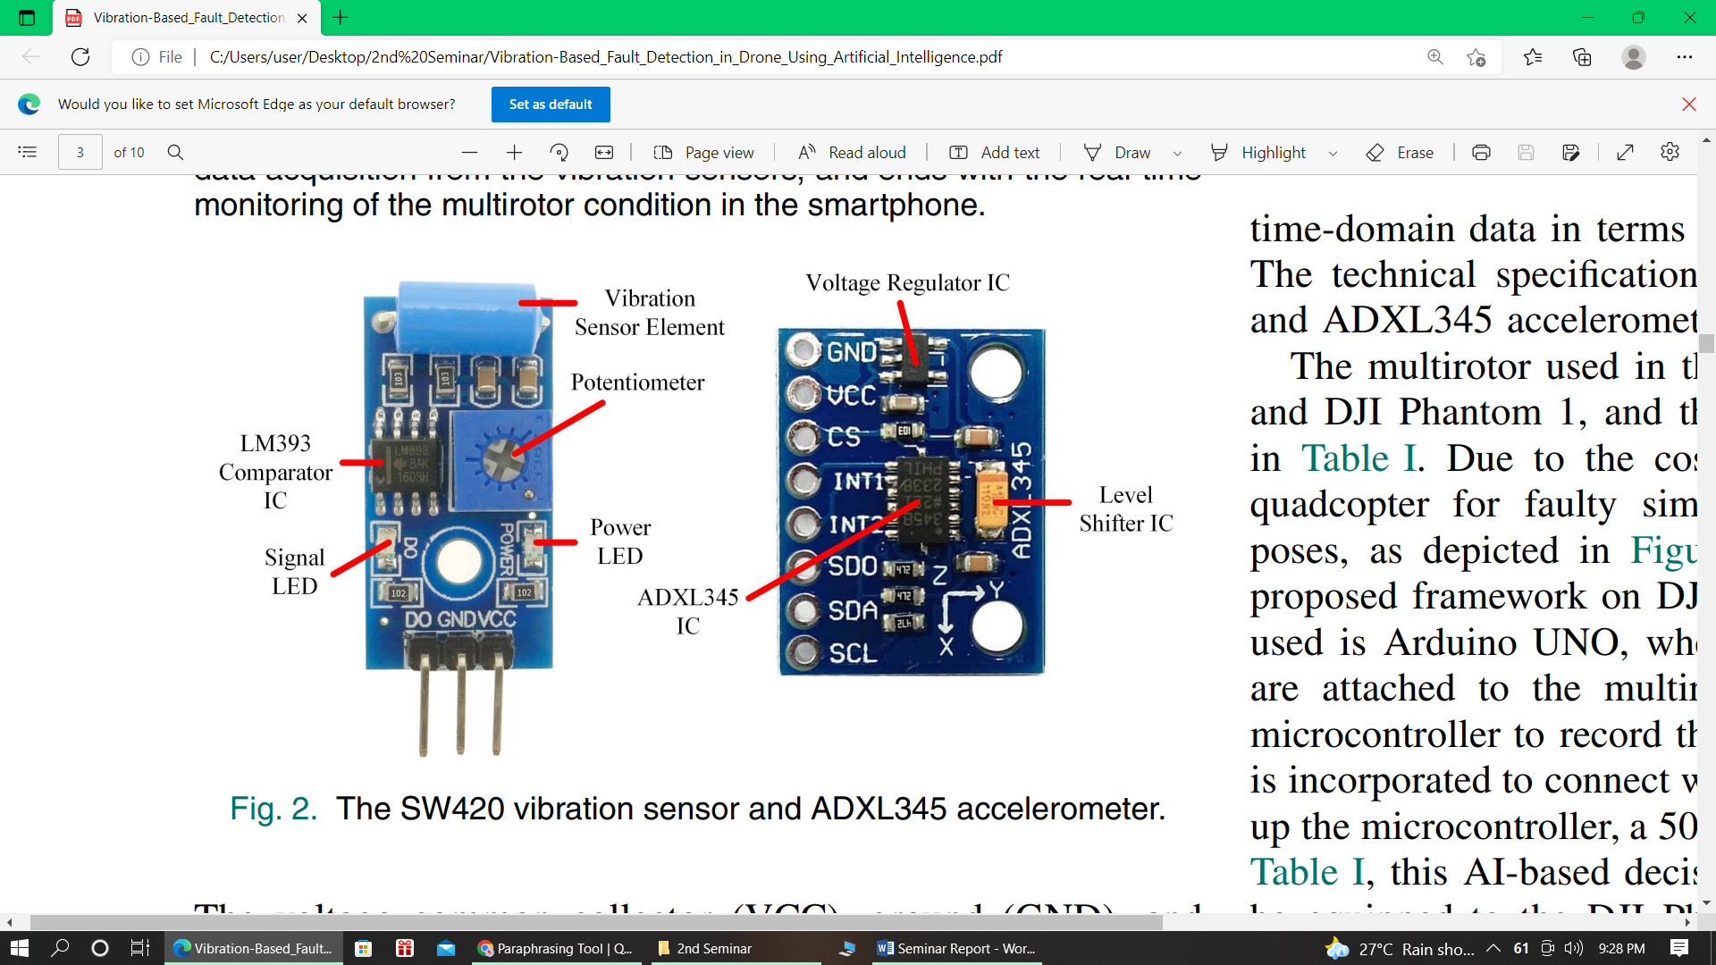

**Figure 2:** The SW420 vibration sensor and ADXL345 accelerometer

The SW420 vibration sensor is chosen for fault detection in multirotor over the popular ADXL345 accelerometer (refer to Figure 2) because it is lighter and easier to install, as it does not require the I2C communication protocol to operate. The SW420 vibration sensor is adequate because of only want to determine the level of vibration. The ADXL345 accelerometer is required to determine the faulty location in the multirotor because frequency information is critical. When using the ADXL345 accelerometer, a Fourier transform technique is required to classify the vibration level in terms of frequency, which is difficult to compute in real-time. The vibration level, however, can still be calculated using time-domain data in terms of x, y, and z acceleration values.

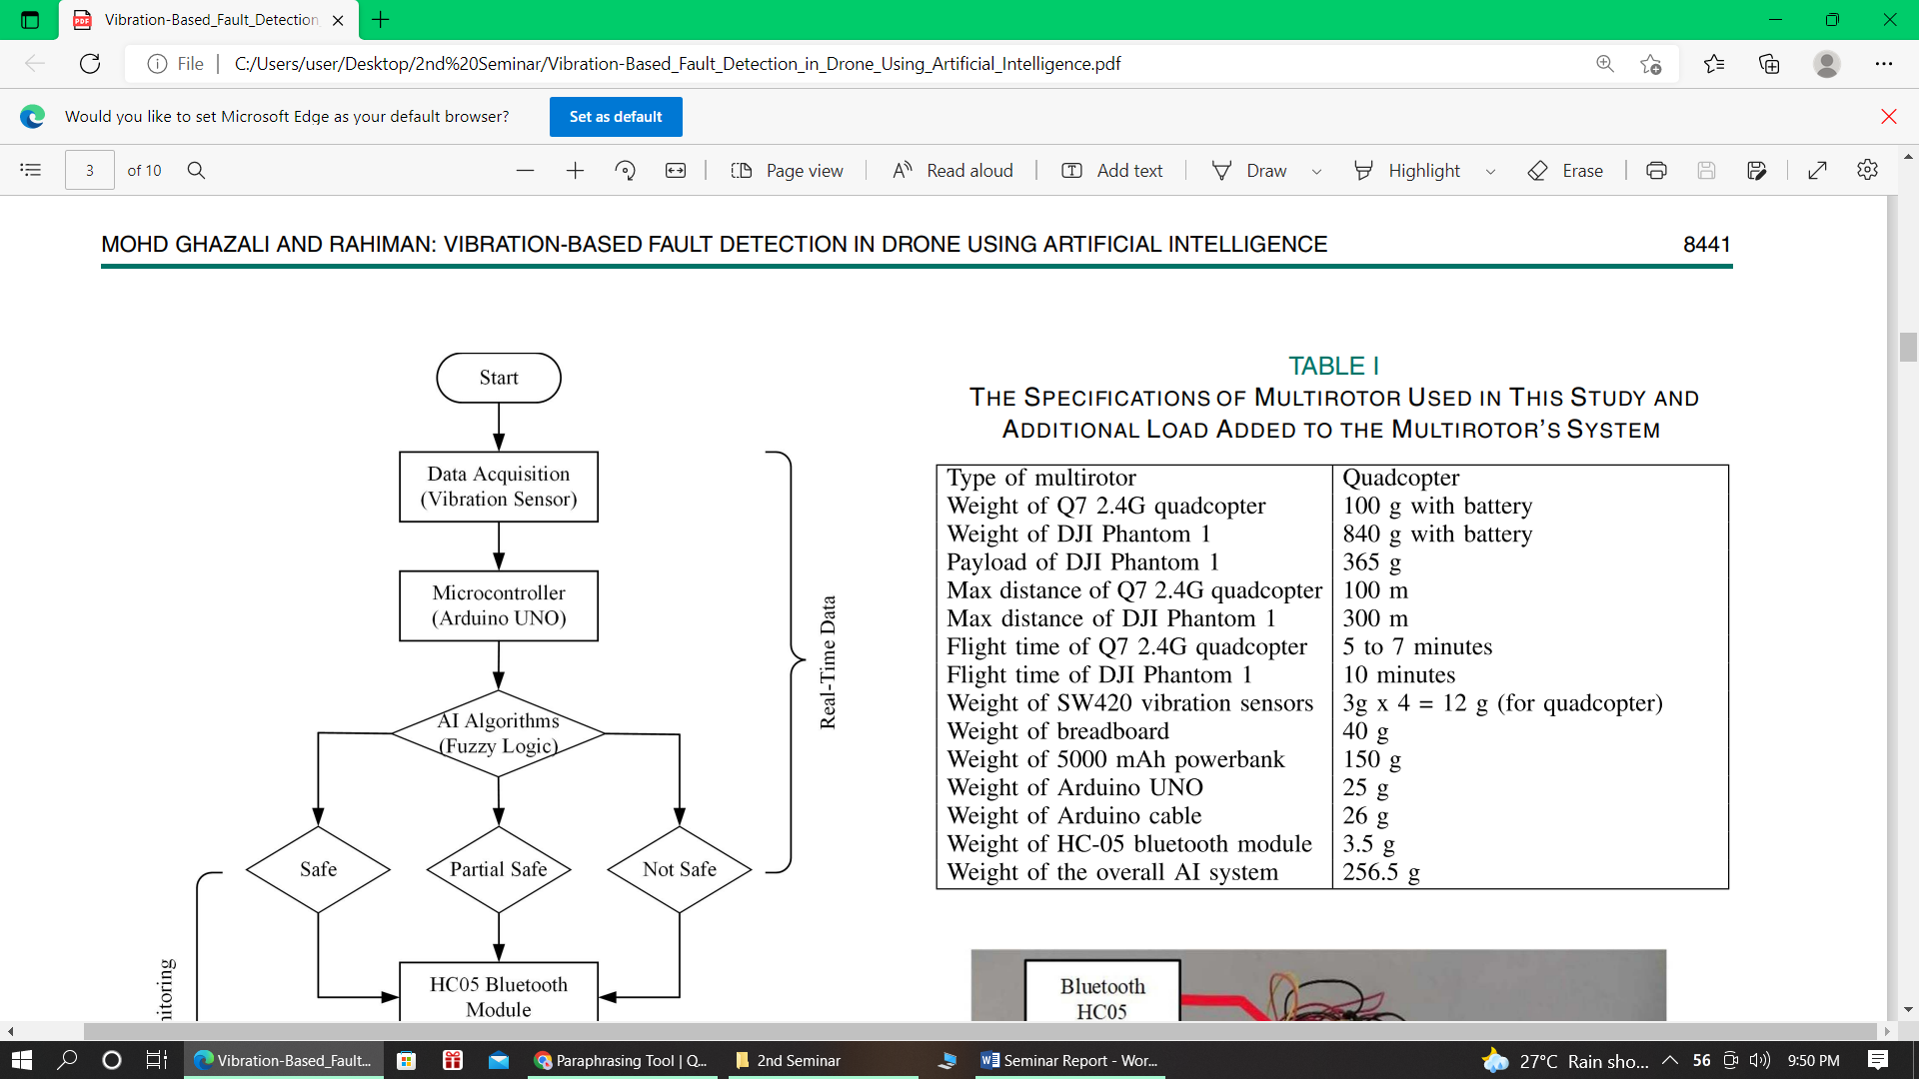

**TABLE 1:** The specification of multirotor used in this study and additional load added to the multirotor system

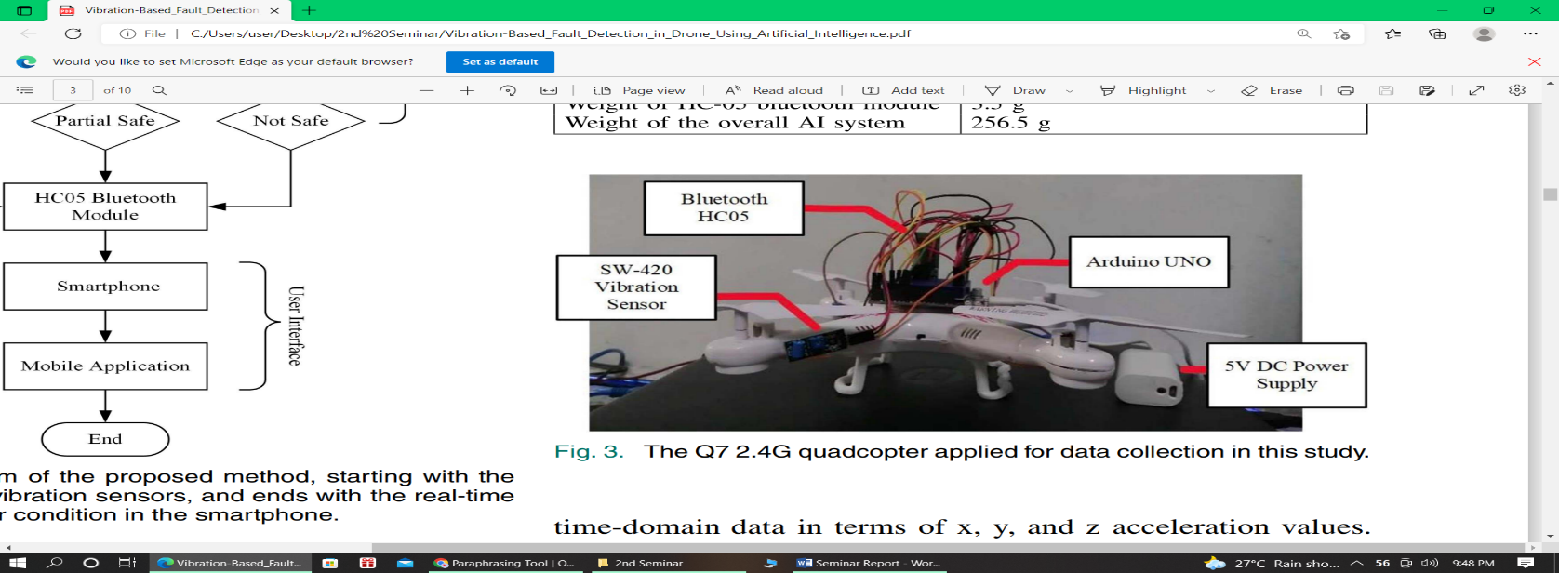

**Figure 3:** The Q7 2.4G quadcopter applied for data collection in this study

Table 1 shows the specifications of the multirotor used in this study, which are the Q7 2.4G quadcopter and the DJI Phantom 1. Because of the cost, Q7 2.4 G quadcopter used for faulty simulation and data collection, as shown in Figure 3. The proposed framework implemented on the DJI Phantom 1. The Arduino UNO microcontroller is used, and four SW420 vibration sensors are attached to the multirotor arms and connected to the microcontroller to record vibration data. Bluetooth HC05 is used to connect with smartphones, and a 5000 mAh power bank is used to power the microcontroller. According to Table I, this AI-based decision-making system is feasible for integration into the DJI Phantom 1 because it would add only 256.5 g to the multirotor, which is less than the maximum

payload (365 g). It demonstrated experimentally when the multirotor successfully took off and hovered with the AI system installed in an indoor environment. For the faulty simulation of multirotor arms, it modified by cutting and joining back using plastic brackets, as shown in Figure 4.

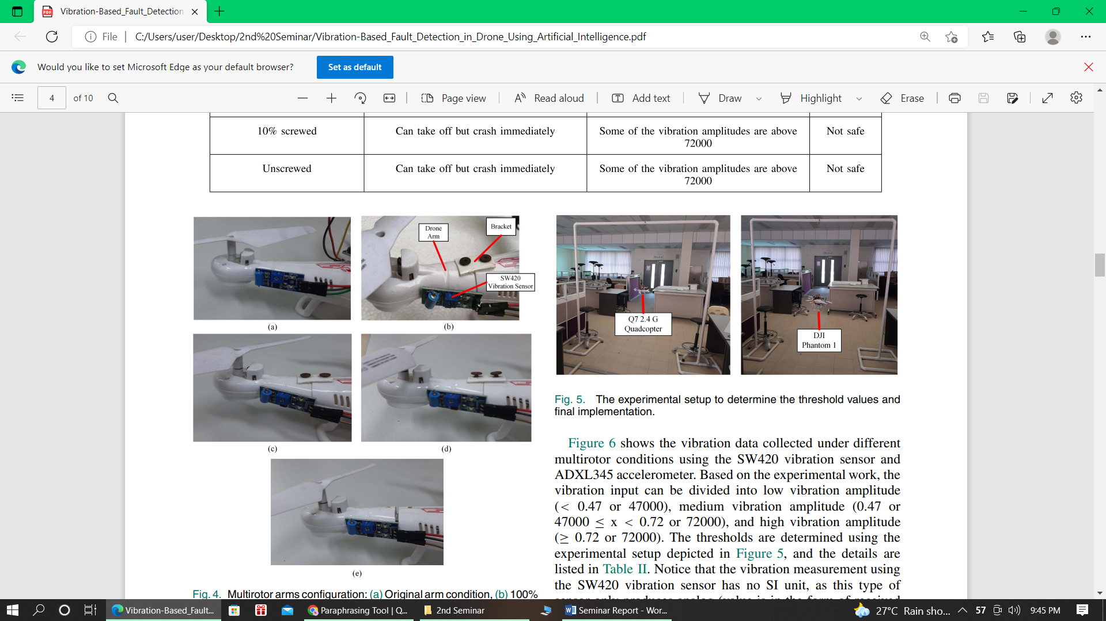

**Fig 4:** Multirotor arms configuration: (a) Original arm condition, (b) 100% screwed (1.5 N.m), (c) 50% screwed (0.7 N.m), (d) 10% screwed (0.3 N.m), and (e) unscrewed multirotor arm.

This bracket can be adjusted to loosen in order to obtain faulty data and tighten in order to obtain normal data. Using an Arduino UNO pulse reading to calibrate the degree of truth for the vibration sensor, the maximum pulse recorded is 100000, so the range was set to 0 to 100000. The pulse value is normalized from 0 to 1 for neuro-fuzzy and NN. All vibration sensors have the same degree of truth since the same motor and vibration sensors were applied. There are five experimental conditions for vibration measurement in this study based on the multirotor arms configuration, as shown in Figure 4. The multirotor arms are tightened using the TSD-200 digital torque screwdriver. The 100%, 50%, and 10% screwed multirotor arms are equal to the torque value of 1.5 N.m, 0.7 N.m, and 0.3 N.m, respectively.

**4. RESULTS AND ANALYSIS**

The real-time data was collected about two minutes for each condition using the Parallax Data Acquisition tool (PLXDAQ) Microsoft Excel add-in. After enabling the Macros, the vibration data can be recorded and plotted automatically in the Excel spreadsheet. These data are collected when the multirotor is on the ground. After collecting the vibration data, at each condition, the drone will take off and hover at a 1 m height using the experimental setup as shown in Figure 5.

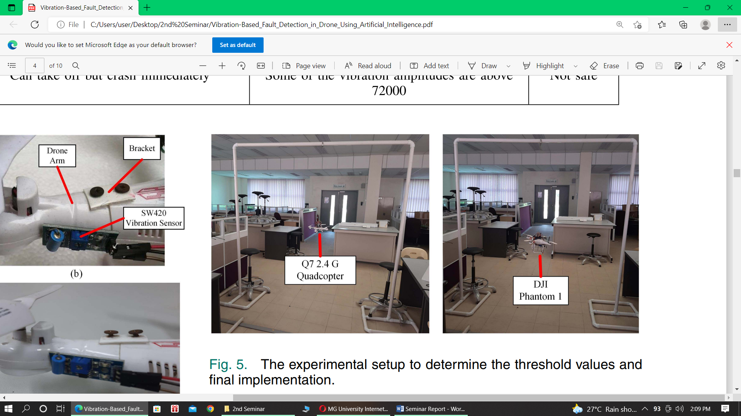

**Figure 5**: The experimental setup to determine the threshold values and final implementation.

Based on the experimental work, the vibration input can be divided into low vibration amplitude (< 0.47 or 47000), medium vibration amplitude (0.47 or 47000 ≤ x < 0.72 or 72000), and high vibration amplitude (≥ 0.72 or 72000). The thresholds are determined using the experimental setup depicted in Figure 5, and the details are listed in Table 2 and not safe state (≥ 0.65).

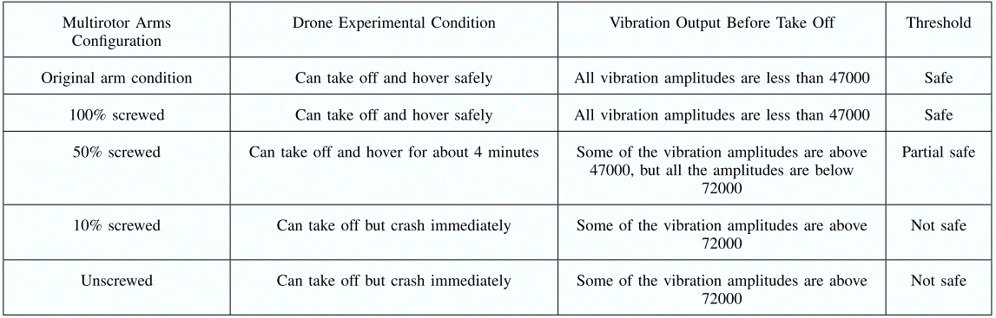

**Table 2** Experimental results to determined threshold values

**4.1 Performance Comparison**

The performance between different AI systems were compared, and the fuzzy logic provided better results as it produced the results closest to the desired value.

**4.2 User interface**

Users are expectedly not familiar with the outputs in decimal form, the MIT app inventor is used to create the application in APK specifically for better and easier monitoring. MIT app inventor is an open-source web application that permits users to design software applications for the Android operating system. It adopts a graphical interface, allowing users to drag-and-drop visual objects to create the desired application using the block-based coding program. The created mobile application can be accessed using a smartphone. Firstly, users have to connect the smartphone with the HC05 Bluetooth module. Then, this application will show three possible decisions, which is green, referring to safe to operate, yellow, referring to partial safe, and red, referring to not safe to operate. This decision-making can be monitored in the smartphone through the application created and the HC05 Bluetooth module, which can be observed in Figure 13.

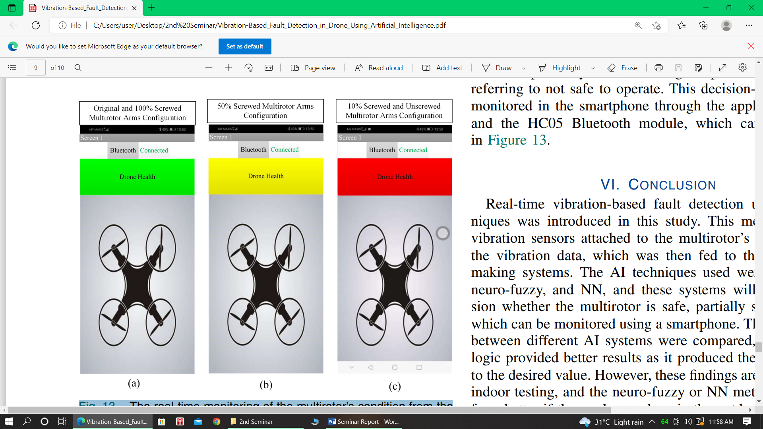

**Figure 13**: The real-time monitoring of the multirotor condition from the smartphone as predicted by the proposed method; (a) green indicator means the multirotor is safe to operate, (b) yellow indicator means the multirotor is partially safe to operate, and (c) red indicator means the multirotor is not safe to operate.

**5. CONCLUSION**

Real-time vibration-based fault detection using AI techniques was introduced in this study. This method used the vibration sensors attached to the multirotor arms to obtain the vibration data, which was then fed to the AI decision making systems. The AI techniques used were fuzzy logic, neuro-fuzzy, and NN, and these systems will make a decision whether the multirotor is safe, partially safe, or unsafe, which can be monitored using a smartphone. The performance between different AI systems were compared, and the fuzzy logic provided better results as it produced the results closest to the desired value. However, these findings are only based on indoor testing, and the neuro-fuzzy or NN method might perform better if the works are done in the outdoor environment. This study is also limited to only one parameter, which is the multirotor arms. This work can be extended by including other parameters such as propeller vibration, motor condition, and battery level. In terms of hardware, the built-in accelerometer of the multirotor system can also be used to measure the vibration, and an algorithm to differentiate between the propeller and multirotor arm vibrations can be developed. This approach avoids the need to install additional sensors to the multirotor and thus provides a potentially simpler and more power-efficient approach to real-time in-flight fault detection. In the future, outdoor experiments or testing will be considered to represent the actual flight condition of the drone in terms of the effect of wind speed, different maneuverability, and aggressiveness.

**REFERENCES**

1. [Mohamad Hazwan Mohd Ghazali](https://ieeexplore.ieee.org/author/37088964695), [Wan Rahiman](https://ieeexplore.ieee.org/author/37946397100) “Vibration-Based Fault Detection in Drone Using Artificial Intelligence”, IEEE Access, vol.22, 2022.
2. Ghalamchi, Z. Jia, and M. W. Mueller, “Real-time vibration-based propeller fault diagnosis for multicopters”, IEEE/ASME Trans. Mechatronics, vol.25, 2020.
3. M. Escano, M. A. Ridao-Olivar, C. Ierardi, A. J. Sanchez, and K. Rouzbehi, “Driver behavior soft-sensor based on neurofuzzy systems and weighted projection on principal components,” IEEE Access, vol.20, 2020.
4. Jalil, G. R. Leone, M. Martinelli, D. Moroni, M. A. Pascali, and A. Berton, “Fault detection in power equipment via an unmanned aerial system using multi modal data,” IEEE Access, vol.19, 2019.
5. Abdulrahman Al-Mashhadani, “Random vibrations in unmanned aerial vehicles, mathematical analysis and control methodology based on expectation and probability,” IEEE Access, vol.38, 2019.